
Touchstones Project
Netcards

Balance Netcards with Text

Clown HRJ
Dream HRJ
Earth HRJ
Emotional HRJ

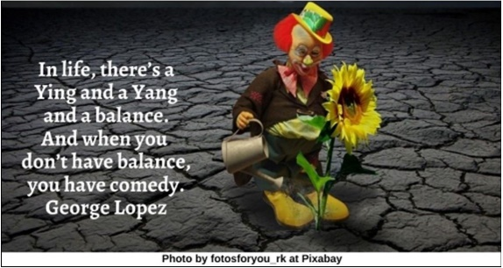

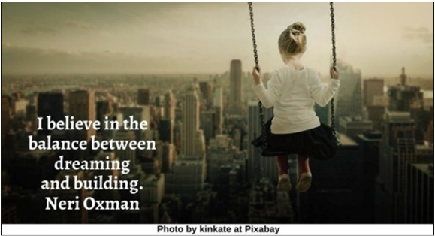

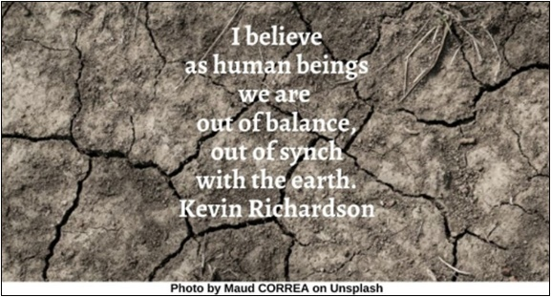

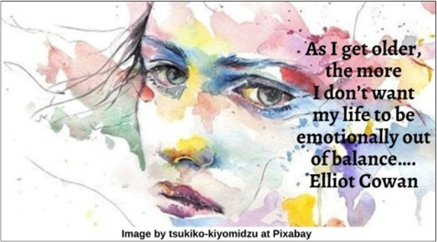

Environmental Damage HRJ
Fortune Cookies HRJ
Good Balance HRJ
Hawaii HRJ

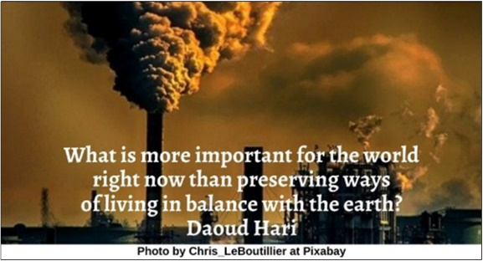

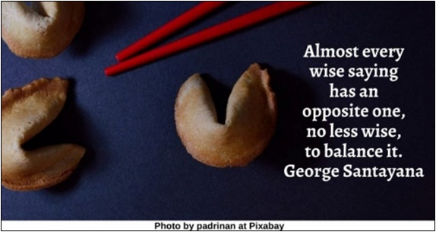

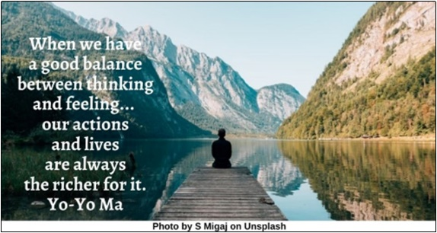

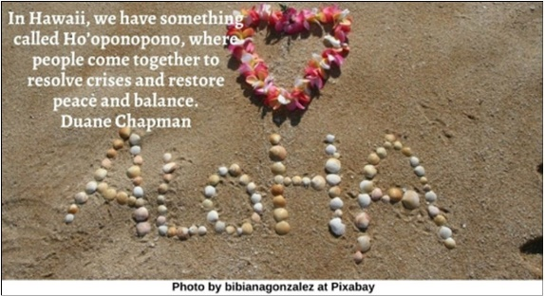

High Wire HRJ
Horizon HRJ
Hourglass HRJ
Laughter HRJ

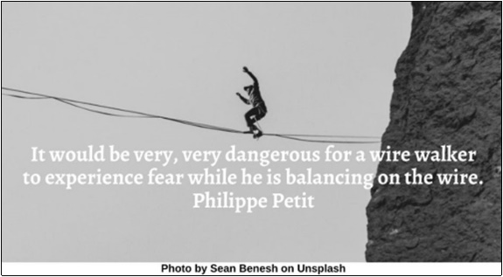

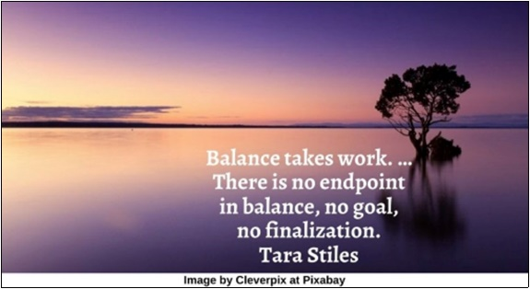

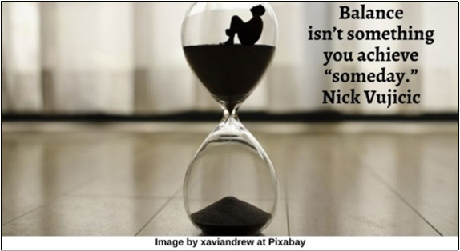

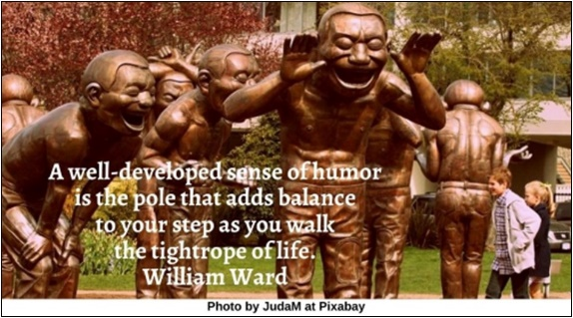

Leisure HRJ
Let Go HRJ
Love HRJ
Mandala HRJ

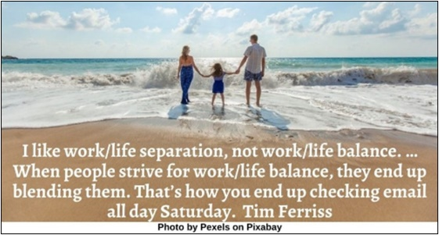



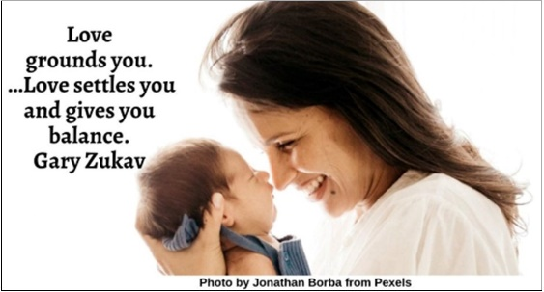

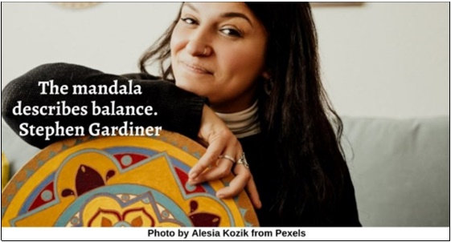

Marathon HRJ
Mirror HRJ
Misery HRJ
Monk HRJ

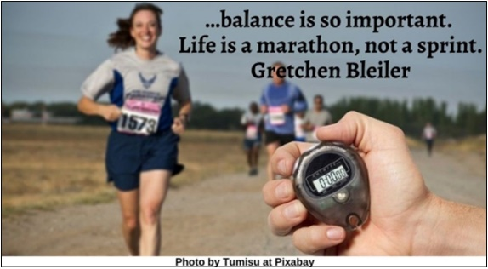

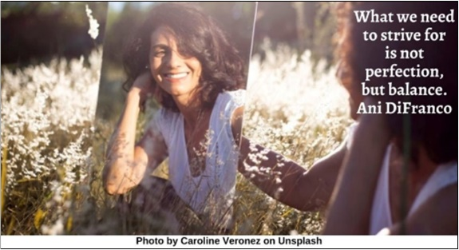

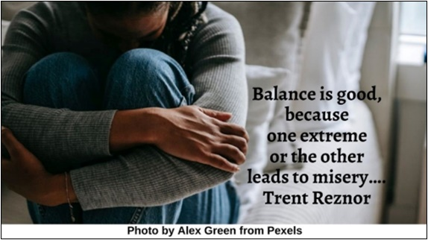

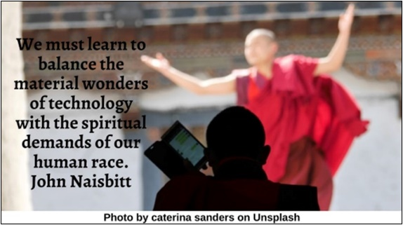

Peace HRJ
Power HRJ
Protest HRJ
Puzzle HRJ

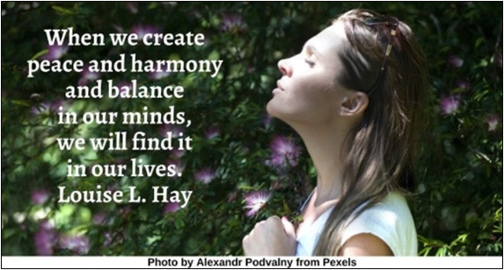

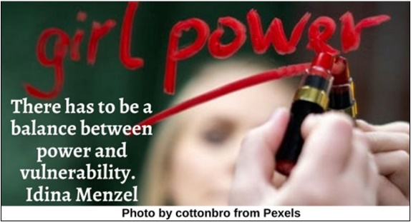

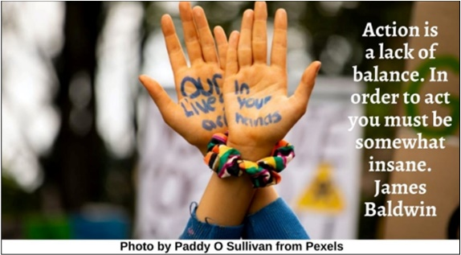



Riding Bicycle HRJ
Self-Care HRJ
Success HRJ
Sunset HRJ

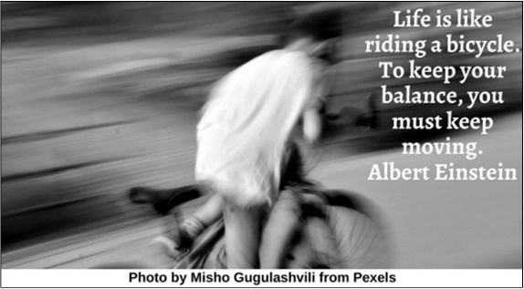

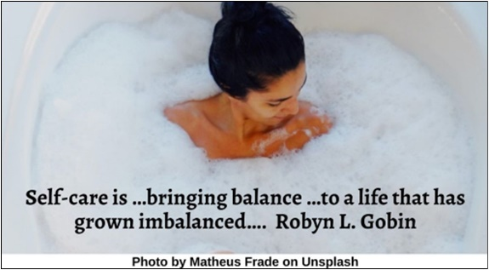

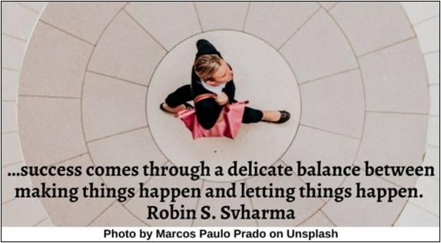

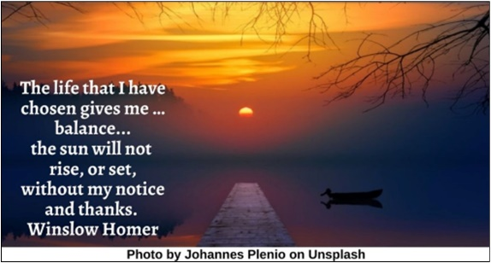

Thinking HRJ
Wolves HRJ
Yin Yang HRJ

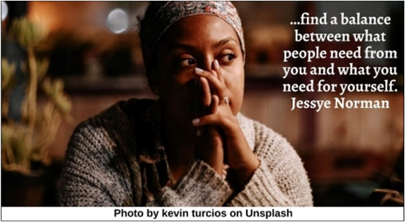

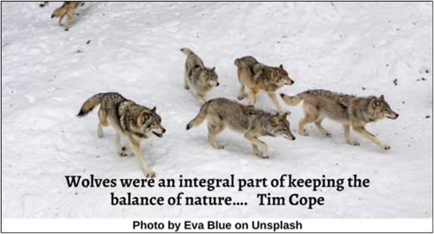

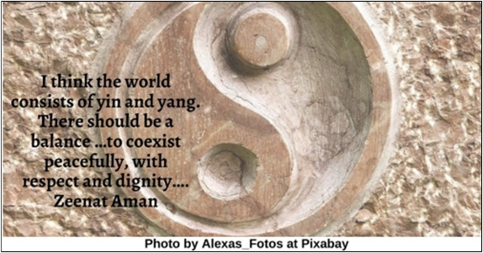

Text of Quotes
Clown HRJ
In life, there’s a Ying and a Yang and a balance. And when you don’t have balance, you have comedy. George Lopez

Dream HRJ
I believe in the balance between dreaming and building. Neri Oxman

Earth HRJ
I believe as human beings we are out of balance, out of synch with the earth. Kevin Richardson

Emotional HRJ
As I get older, the more I don’t want my life to be emotionally out of balance…. Elliot Cowan

Environmental Damage HRJ
What is more important for the world right now than preserving ways of living in balance with the earth? Daoud Hari

Fortune Cookies HRJ
Almost every wise saying has an opposite one, no less wise, to balance it. George Santayana

Good Balance HRJ
When we have a good balance between thinking and feeling... our actions and lives are always the richer for it. Yo-Yo Ma

Hawaii HRJ
In Hawaii, we have something called Ho’oponopono, where people come together to resolve crises and restore peace and balance. Duane Chapman

High Wire HRJ
It would be very, very dangerous for a wire walker to experience fear while he is balancing on the wire. Philippe Petit

Horizon HRJ
Balance takes work. …There is no endpoint in balance, no goal, no finalization. Tara Stiles

Hourglass HRJ
Balance isn’t something you achieve “someday.” Nick Vujicic

Laughter HRJ
A well-developed sense of humor is the pole that adds balance to your step as you walk the tightrope of life. William Ward

Leisure HRJ
I like work/life separation, not work/life balance. …When people strive for work/life balance, they end up blending them. That’s how you end up checking email all day Saturday. Tim Ferriss

Let Go HRJ
Letting go helps us to live in a more peaceful state of mind and helps restore our balance. Melody Beattie

Love HRJ
Love grounds you. …Love settles you and gives you balance. Gary Zukav

Mandala HRJ
The mandala describes balance. Stephen Gardiner

Marathon HRJ
…balance is so important. Life is a marathon, not a sprint. Gretchen Bleiler

Mirror HRJ
What we need to strive for is not perfection, but balance. Ani DiFranco

Misery HRJ
Balance is good, because one extreme or the other leads to misery…. Trent Reznor

Monk HRJ
We must learn to balance the material wonders of technology with the spiritual demands of our human race. John Naisbitt

Peace HRJ
When we create peace and harmony and balance in our minds, we will find it in our lives. Louise L. Hay

Power HRJ
There has to be a balance between power and vulnerability. Idina Menzel

Protest HRJ
Action is a lack of balance. In order to act you must be somewhat insane. James Baldwin

Puzzle HRJ
…order …is a perfect balance between the needs of the parts, and the needs of the whole. Christopher Alexander

Riding Bicycle HRJ
Life is like riding a bicycle. To keep your balance, you must keep moving. Albert Einstein

Self-Care HRJ
Self-care is …bringing balance …to a life that has grown imbalanced…. Robyn L. Gobin

Success HRJ
…success comes through a delicate balance between making things happen and letting things happen. Robin S. Svharma

Sunset HRJ
The life that I have chosen gives me …balance of my life: the sun will not rise, or set, without my notice and
thanks. Winslow Homer

Thinking HRJ
…find a balance between what people need from you and what you need for yourself. Jessye Norman

Wolves HRJ
Wolves were an integral part of keeping the balance of nature…. Tim Cope

Yin Yang HRJ
I think the world consists of yin and yang. There should be a balance …to coexist peacefully, with respect and dignity…. Zeenat Aman

